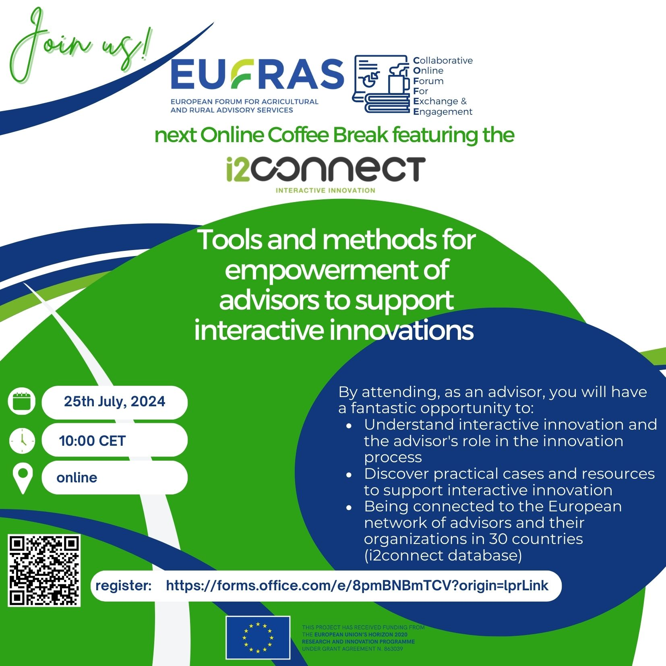

Don't miss out!
Register now: https://forms.office.com/e/8pmBNBmTCV?origin=lprLink
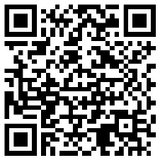

https://www.eufras.eu/join-us-for-the-next-eufras-online-coffee-break-featuring-the-i2connect-project-tools-and-methods-for-empowerment-of-advisors-to-support-interactive-innovations

https://www.facebook.com/photo?fbid=495283989530177&set=a.195140449544534

Looking forward to seeing you there!

